*Contractor eTRAKiT Quick Start Guide*

City of Commerce City

City of Commerce City

City of Commerce City

City of Commerce City

[About This Document 1](https://c3gov-my.sharepoint.com/personal/bbuonanno_c3gov_com/Documents/Documents/Beth%20Buonanno%20work/User%20Guide/Quick%20Start/Building%20Contractor%20Quick%20Start%20Guide.docx#_Toc134686512)

[Audience 1](https://c3gov-my.sharepoint.com/personal/bbuonanno_c3gov_com/Documents/Documents/Beth%20Buonanno%20work/User%20Guide/Quick%20Start/Building%20Contractor%20Quick%20Start%20Guide.docx#_Toc134686513)

1 New Contractor Login Instructions 2

1.1 Applying for a Contractor License 2

1.2 Logging on to your License 10

1.2.1 Using the Top Green Bar to Login 10

1.2.2 Logging in via Permit > Apply 11

2 Existing Contractors: Creating Password 13

2.1 Creating your Password 13

2.2 Logging in Moving Forward 14

About This Document

The Building Contractor *eTRAKiT Quick Start Guide* provides step-by-step instructions for:

* New Contractors: Requesting a building Contractor’s license or,
* Existing Contractors: Creating a new password using eTRAKiT.

Audience

This document is intended for use by:

* New city contractors applying contractor’s license.
* Existing city contractors needing to create a password for this new system.

# New Contractor Login Instructions

## Applying for a Contractor License

To work in the City of Commerce City, as a contractor you must obtain a license for your trade.

To obtain a contractor’s license, do the following:

1. Open the eTRAKiT Home Page.

The Home Page displays.

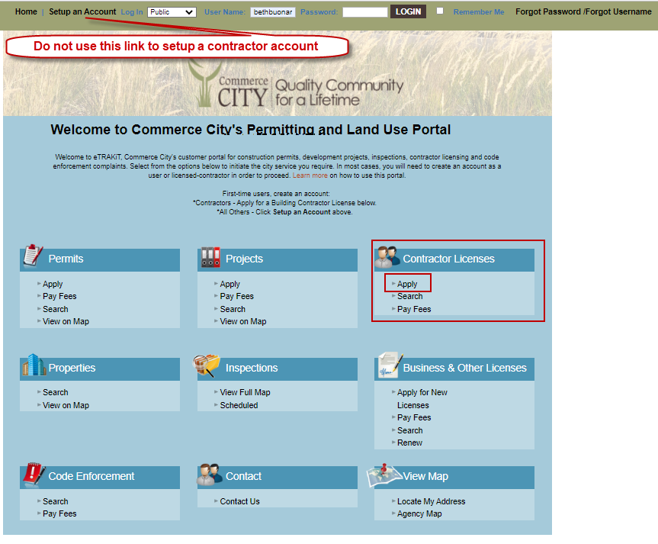

1. Under Contractor Licenses heading, click Apply.

The AEC Application Confirmation screen displays.

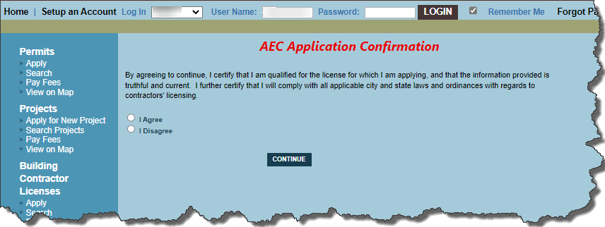

1. Check the check box for I Agree and click Continue.

The AEC Application displays.

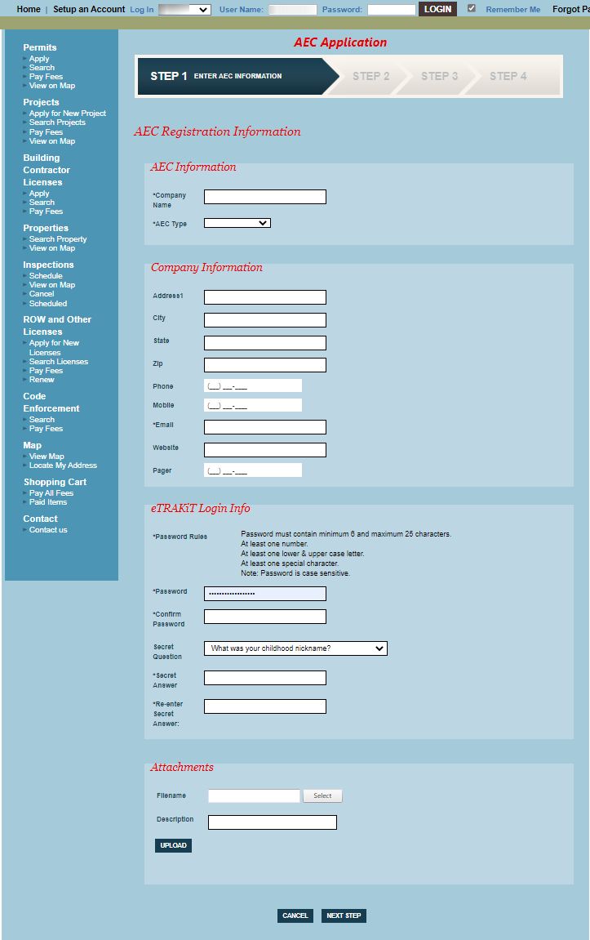

1. Enter the following information on the application:

AEC Registration Information

AEC Information

* Required

| R | Field | Description |
| --- | --- | --- |
|  | AEC Information |  |
| * | Company Name | Type you company’s name. |
| * | AEC Type | From the drop-down list, select the AEC Type.  Only one selection is allowed. |
|  | Company Information |  |
|  | Address1 | Type your address. |
|  | City | Type your city. |
|  | State | Type your state abbreviation. |
|  | Zip | Type your zip code xxxxx or xxxxx-xxxx |
|  | Phone | Type your phone number—numbers only. |
|  | Mobile | Type your phone number—numbers only. |
| * | Email | Type your email address. |
|  | Website | Type the URL for your Web site. |
|  | Pager | Type your pager number—numbers only. |
|  | eTRAKiT Login Info |  |
|  | Password must contain minimum 6 and maximum 25 characters, and  At least one number. and | At least one lower- & upper-case letter, and  At least one special character.  *Note:* Password is case sensitive. |
| * | Password | Using the above guidelines, type your password. |
| * | Confirm Password | Confirm the password you typed above. |
|  | Secret Question | From the drop-down list, select a question. |
| * | Secret Answer | Type your secret answer. Case is recognized. |
| * | Re-enter Secret Answer | Retype your secret answer. Case is recognized. |
|  | For Class A, B, C, Mechanical, & Roofing Licenses |  |
| * | Insurance Expiration Date | Using the calendar Picture of calendar icon icon, select the expiration of your insurance. |
| * | Have you attached your proof of insurance? | If applicable, from the drop-down list, select Yes.  **Important:** You will need to attach a picture of insurance below. |
| * | Have you attached your proof of testing? | From the drop-down list, make a selection. |
|  | Is this a renewal only? | From the drop-down list, make a selection. |
|  | For Plumbing & Electrical Licenses |  |
| * | State License Expiration | Using the calendar Pciture of calendar icon icon, select the expiration of your state license. |
| * | Insurance Expiration Date | Using the calendar Picture of calendar icon icon, select the expiration of your insurance. |
| * | Have you attached your proof of insurance? | If applicable, from the drop-down list, select Yes.  You will need to attach a picture of insurance below. |
| * | Have you attached your state contractor and master licenses? | From the drop-down list, make a selection.  You will need to attach a picture of your licenses below. |
|  | Is this a renewal only? | From the drop-down list, make a selection. |
|  | For Specialty Licenses |  |
| * | Insurance Expiration Date | Using the calendar Picture of calendar icon icon, select the expiration of your insurance. |
| * | Have you attached your proof of insurance? | If applicable, from the drop-down list, select Yes.  You will need to attach a picture of insurance below. |
|  | Is this a renewal only? | From the drop-down list, make a selection. |

Attachments

Ensure to include required attachments with your application. Failure to do so may delay in the issuance of your permit.

* 1. Click **Select** and locate the appropriate file.
  2. Enter a **Description** of the file.
  3. Click **Upload**.

The following message displays:

Please ensure that *all required* attachments are included with the application. Failure to include all required materials will delay the application process. Attachments will not be returned once submitted. Attachments become the property of Commerce City.

* 1. Click **Accept**.

The system displays the file as uploaded.

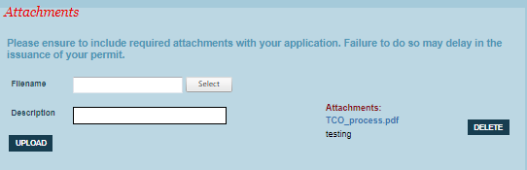

* 1. As needed, upload additional files.

*Note:* You may upload more than one file at a time. In this instance, provide a separate description of each uploaded file.

1. Click Next Step.

The AEC Application screen displays.

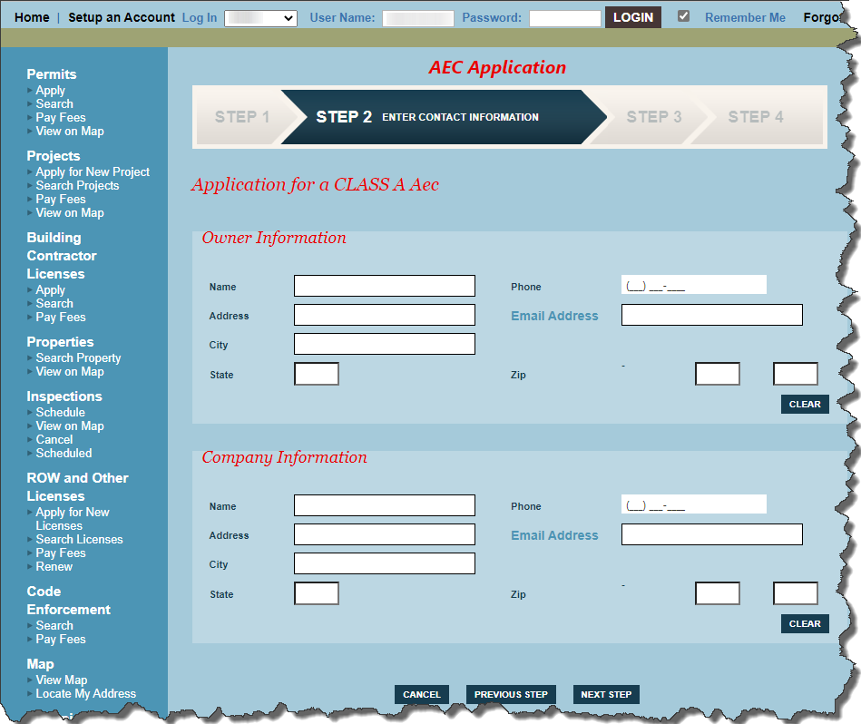

*Note:* The sample screen below is based on a Class A AEC.

1. As needed, enter contact information, and click Next Step.

*Note:* Depending on AEC Type selected on the first screen, other contact sections may be displayed.

The Review and Submit screen displays.

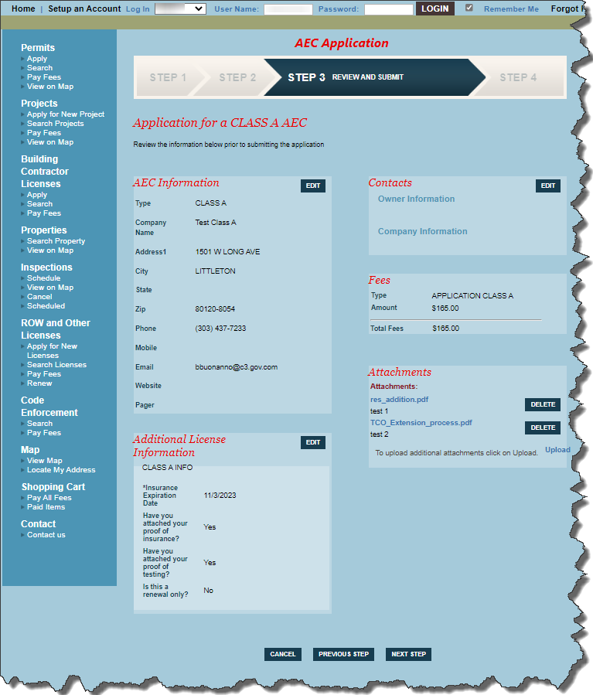

This screen provides a summary of your entries. If there is a fee, it is also listed.

*Note:* In this example, a fee is due.

* If fees are due, go to step 7.
* If fees are not due, the final screen displays—go to step 8.

1. To pay the permit fees, click **Next Step,** and then pay using desired method.
   1. Enter Payment Information, and click Next Step: Review Payment.

The Review Payment screen displays.

* 1. Review payment and Billing Information, click the I Agree statement, and click Make Payment.

You are returned to the Step 4: Payment screen.

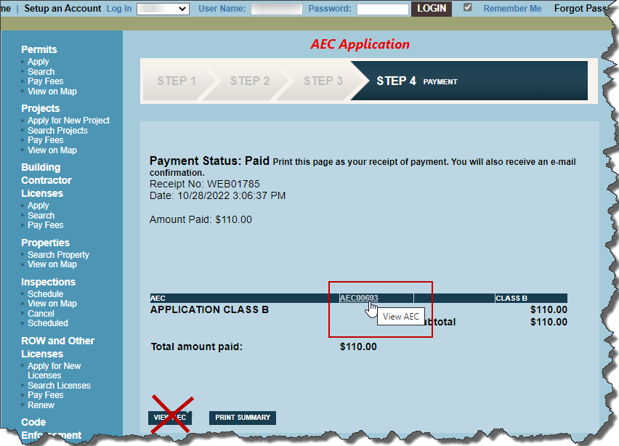

In your email, you will receive the following:

* + - A notification thanking you for your online order.
    - A payment receipt.

1. Hover over AEC Record # and click the View AEC hyperlink.

The following screen displays.

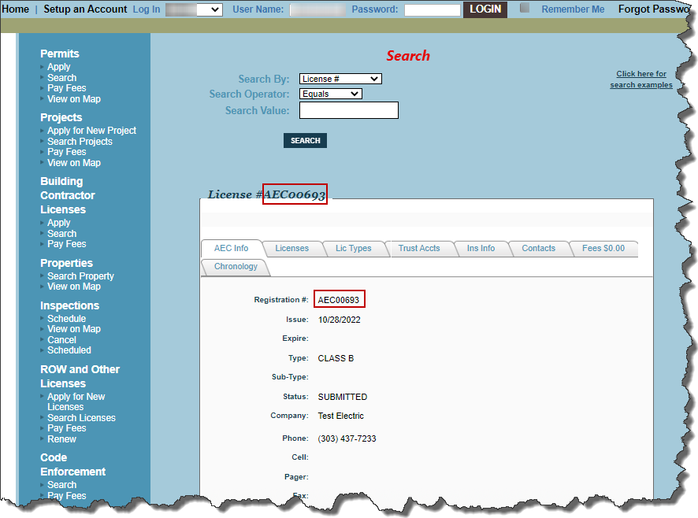

1. **Important:** On the View AEC screen, ensure you copy the AEC license number. This number is used as your UserID when you login to eTRAKiT to work with your license.

**Important:** Until your license application is approved by the City of Commerce City, you will not be able to apply for permits, projects, Right of Way or other licenses, under your AEC license.

## Logging on to your License

There are *two* ways to access your contractor login: 1) using the login on the top green bar or 2) Clicking Permits > Apply.

**Important:** Until your license application is approved by the City of Commerce City, you will not be able to apply for permits, projects, Right of Way or other licenses, under your AEC license.

Once your contractor license is approved, you can login to your AEC account to process transactions.

### Using the Top Green Bar to Login

To login to your AEC account.

1. Go the eTRAKiT home page, top green bar.

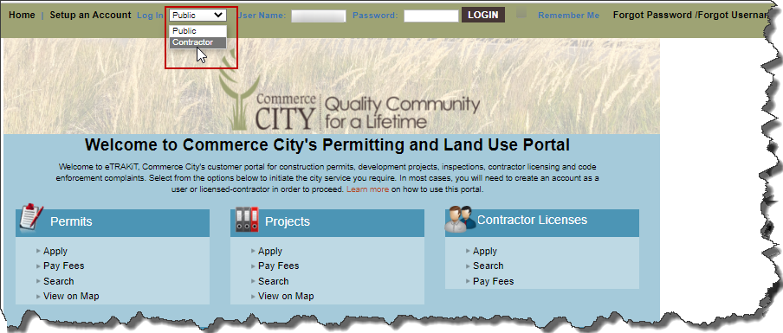

1. Do the following:
   1. From the Log In dropdown list, select Contractor.
   2. For User Name, type the AEC Record Number (for example AEC00699).
   3. For Password, type your password you chose when you requested your license.
   4. Click Login.

Your license’s home screen displays any activities you have. This example has no current activity.

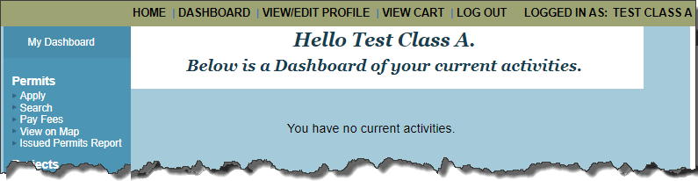

1. Perform any of the activities displayed on the left blue navigation bar as needed.

### Logging in via Permit > Apply

To login to your AEC account.

1. Go the eTRAKiT home page.

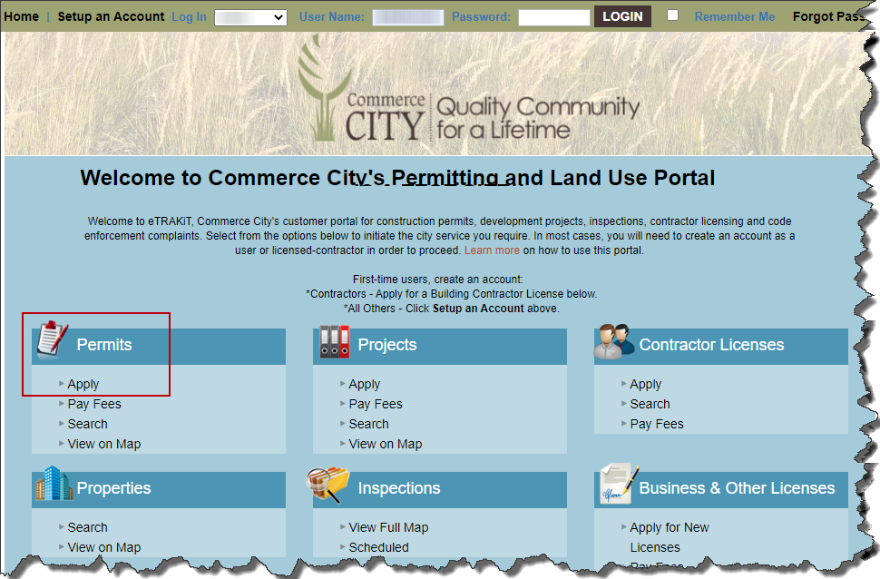

1. As shown above in the red square, under Permits/Projects/ROW and Other Licenses, click Apply.

The Contractor Login displayed.

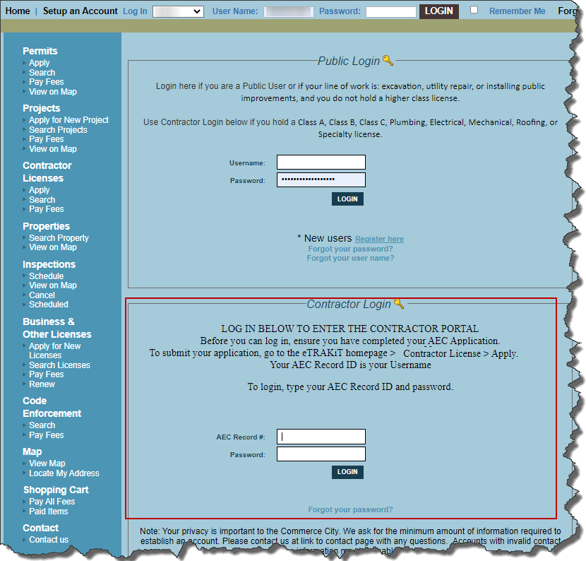

1. Under Contractor Login, do the following:
   1. For User Name, type the AEC Record Number (for example AEC00699).
   2. For Password, type your password you chose when you requested your license.
   3. Click Login.

Your license’s home screen displays any activities you have. This example has no current activity.



1. Perform any of the activities displayed on the left blue navigation bar as needed.

# Existing Contractors: Creating Password

As an existing contractor, you already have an AEC number. To use the new eTRAKiT system, you need to create a password.

## Creating your Password

Follow the instructions below to create a password in eTRAKiT:

1. Go to the eTRAKiT Homepage [eTRAKiT (csqrcloud.com)](https://comc.csqrcloud.com/community-etrakit/).

The Home page displays.

1. On the top navigation bar, click **Forgot Password**.

The following prompt displayed.



1. At the prompt “Please select one of the options below to begin the password recovery process” click **Contractor**.

The request for your AEC Record # displays.

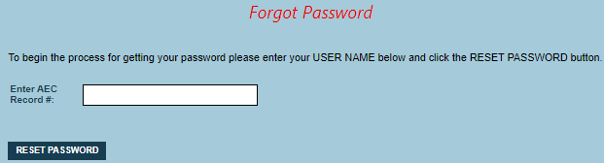

1. In the Enter AEC Record # field, enter your existing City of Commerce City license number.

You will receive another email instructing you to click Reset Password. You must have a current email address on file for your contractor license with Commerce City. If you need to update this, please call the permit desk for assistance.

1. FROM THAT email, click **Reset Password**.

The Reset Password screen displays.

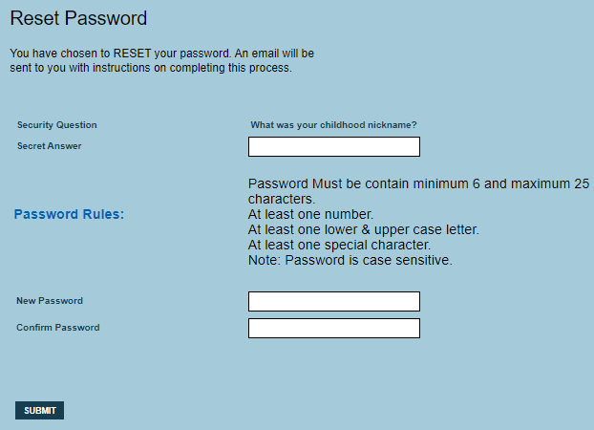

1. For the Security Question, type your answer.
2. Type your new password using the guidelines listed on the screen.
3. Confirm your password and then click **Submit**.

The message “Your USER PASSWORD has been reset. Thank You.”

You will also receive an email confirmation titled “Password reset confirmation for your City of Commerce City C3Permits Account.”

1. Click Continue.

The Home Page displays.

1. From the top navigation bar, click Dashboard to view your existing work.

## Logging in Moving Forward

1. Go to the eTRAKiT Homepage [eTRAKiT (csqrcloud.com)](https://comc.csqrcloud.com/community-etrakit/).

The Home page displays.

1. On the top navigation bar, from the Login drop-down, list, select **Contractor**.



1. In the User Name field, type your **AEC Record #.**
2. In the Password field, type your **Contractor password**.
3. Click **Login**.

Your Dashboard displays your current work.